Mini Project: Axure

Name: _Syukur Sidiq Nur Alam Cohort: BDSE07-UIF

1. **Home Page**

This is The Home Page of XYZ Tution.

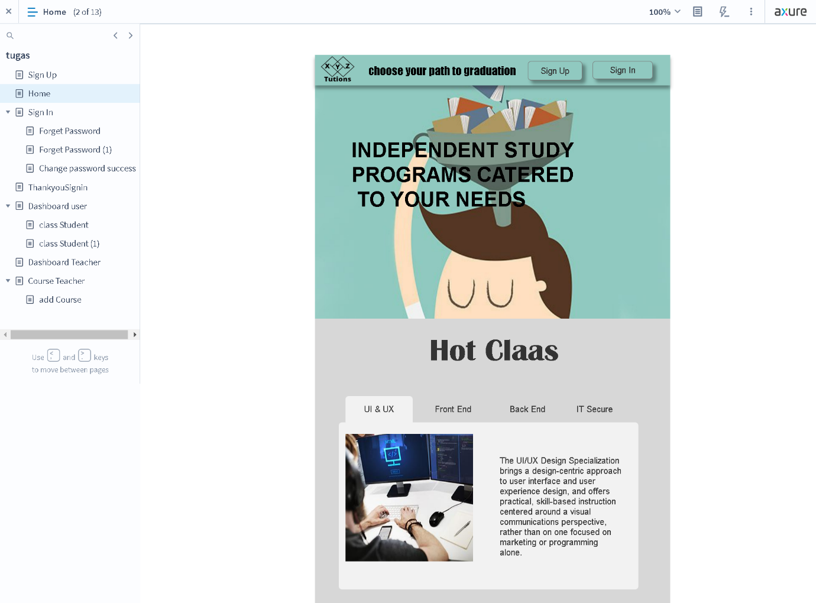

1. **Sign Up**

This is The Student Sign Up Page

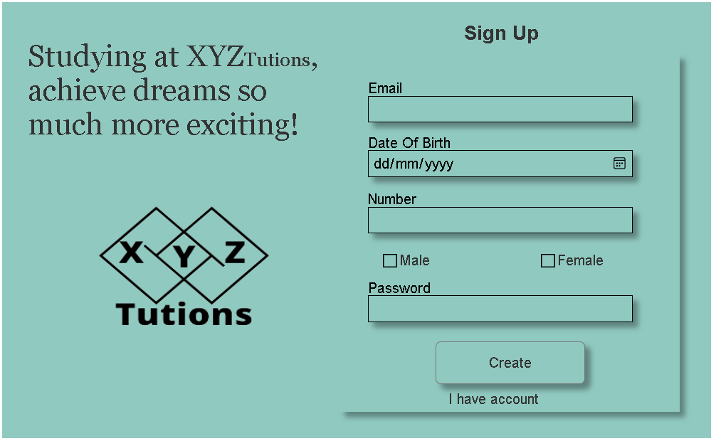

1. **Sign In**

This is The Login Page for students and teachers.

The Teacher’s email is [Teacher@gmail.com](mailto:Teacher@gmail.com), and the password is Teacher.

The student’s email is [syukur@gmail.com](mailto:syukur@gmail.com), and the password is syukur.

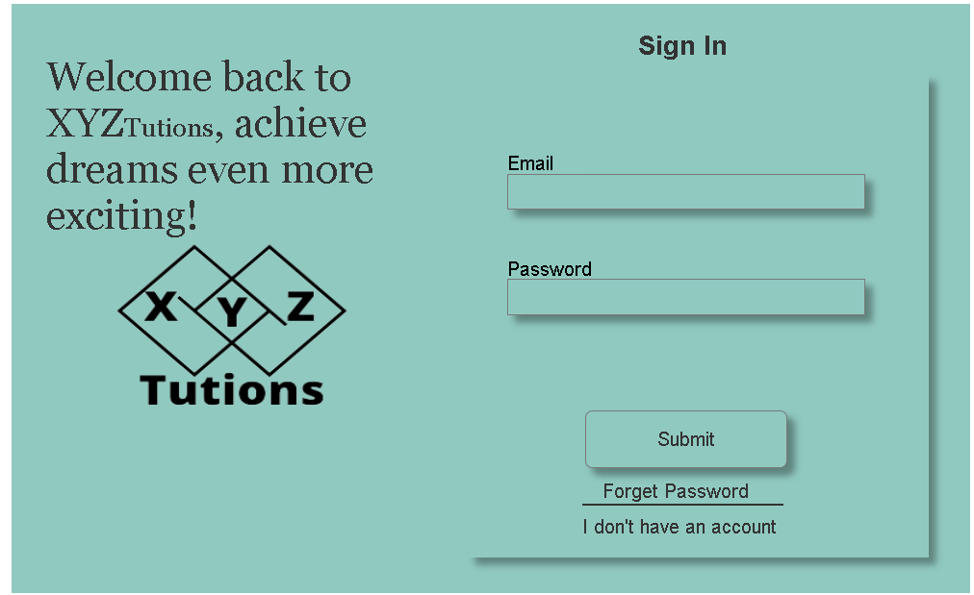

1. **Forget password**

This is the Forgot Password page. If a student forgets their password, they'll need to enter an email to receive the Change password link

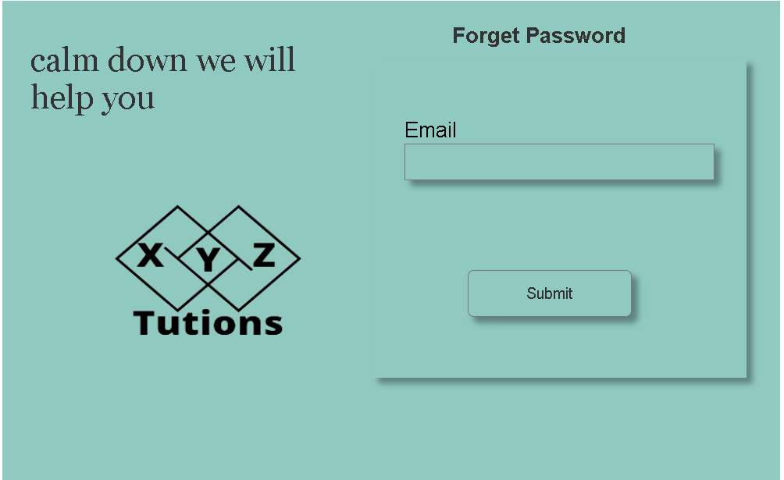

1. **Forget password (2)**

This forgot the page2 password. Students can change a new password

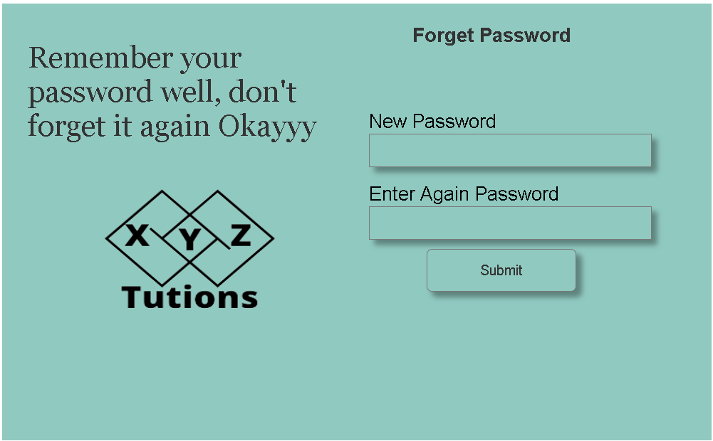

1. **Change password success**

When changing the password success the thank you page will show.

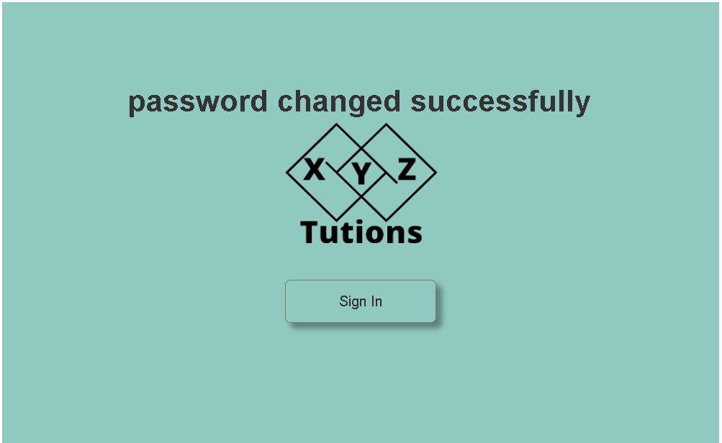

1. **Thank you Sign In**

After the teacher or student login, they will go to the success page first. Next, click Sign In button.



1. **Dashboard student**

On this page, students can view courses they have and take a look at them.

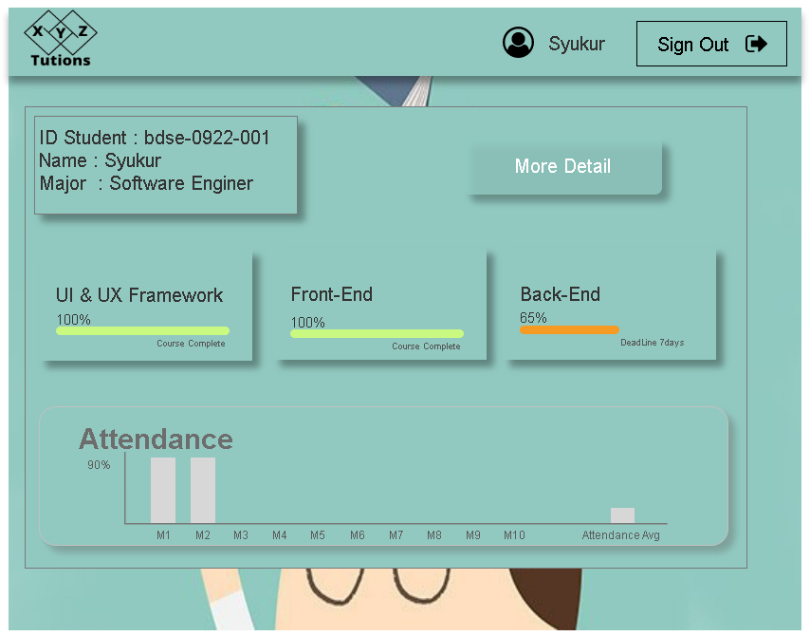

1. **Class Student**

**On this page, students can chooise courses**



1. **Class Student (1)**

**On this page, students can see the detail courses**

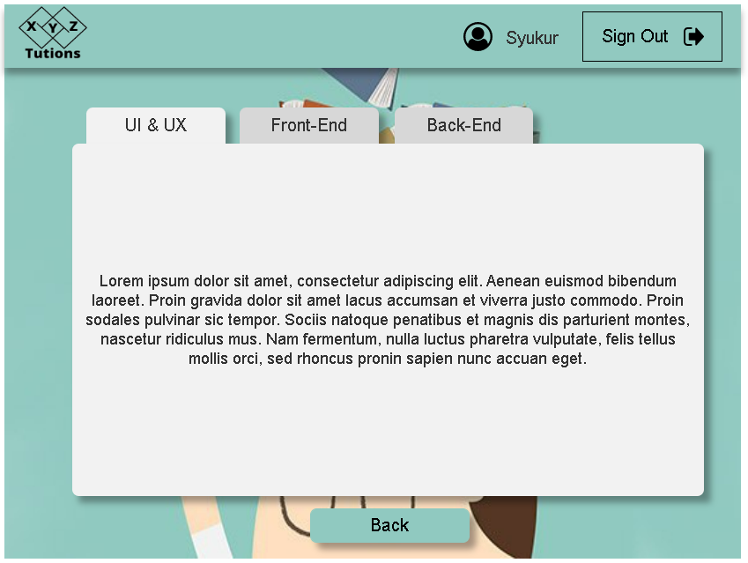

1. **Dashboard Teacher**

In the dashboard, the teacher can view all of the courses.

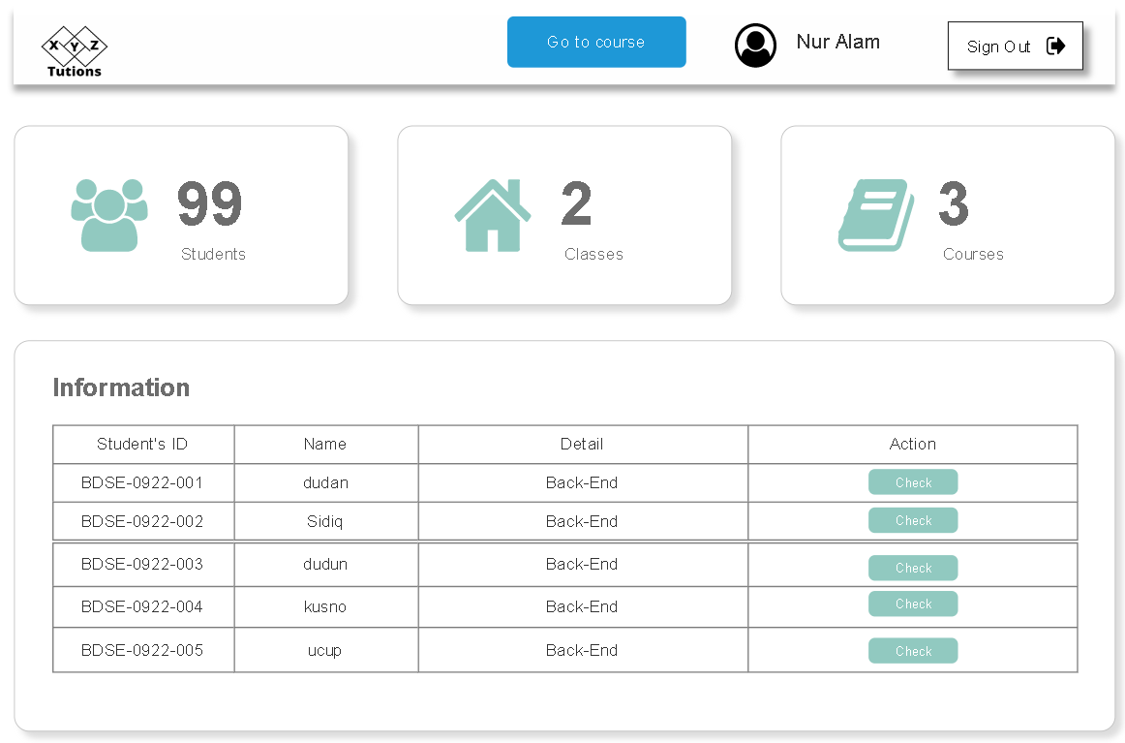

1. **Course Teacher**

On this page teachers can view the content of course and also can add new materials.

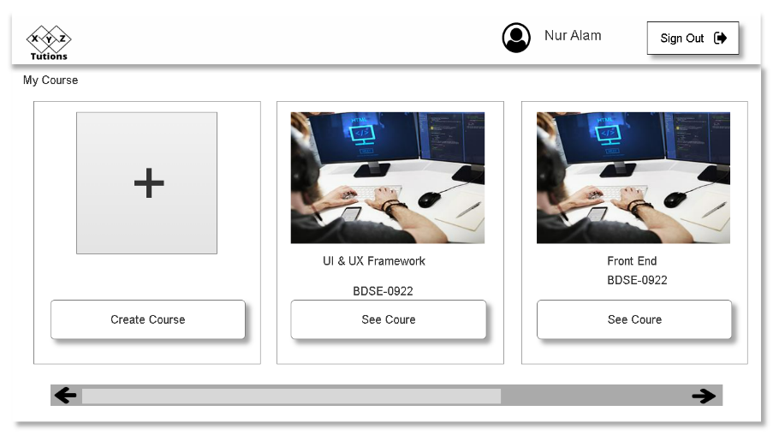

1. **Add Course**

On this page, teacher can make a new course or materials

